Research Title

^{*1} Mohammed Ali Al-Ansari, ² Name Name Title, ¹ Name Name Title,

¹ Structures Department, Building Research Directorate, Baghdad, Iraq.
² Civil Engineering Department, University of Technology, Baghdad, Iraq.

ABSTRACT
The wide range of structural problems resulting from the corrosion of rebar in the structural sections make it one of the important problems …

Keywords: Corrosion, Durability, …, …, ….

* Corresponding author: Mohammed Ali Al-Ansari - mohammedaliansari@yahoo.com

- INTRODUCTION
The countries of the Arabian Gulf region are exposed to the problem of corrosion of reinforcing steel in reinforced concrete structures more severely as a result ...
  - Corrosion of Steel Reinforcement in Concrete
Corrosion of steel is an electrochemical process that occurs at the surface between ...
- Steel decomposes from the anode in the form …
$$2Fe→{2Fe}^{+2}+{4e}^{-}$$ | $$Eq.(1)$$
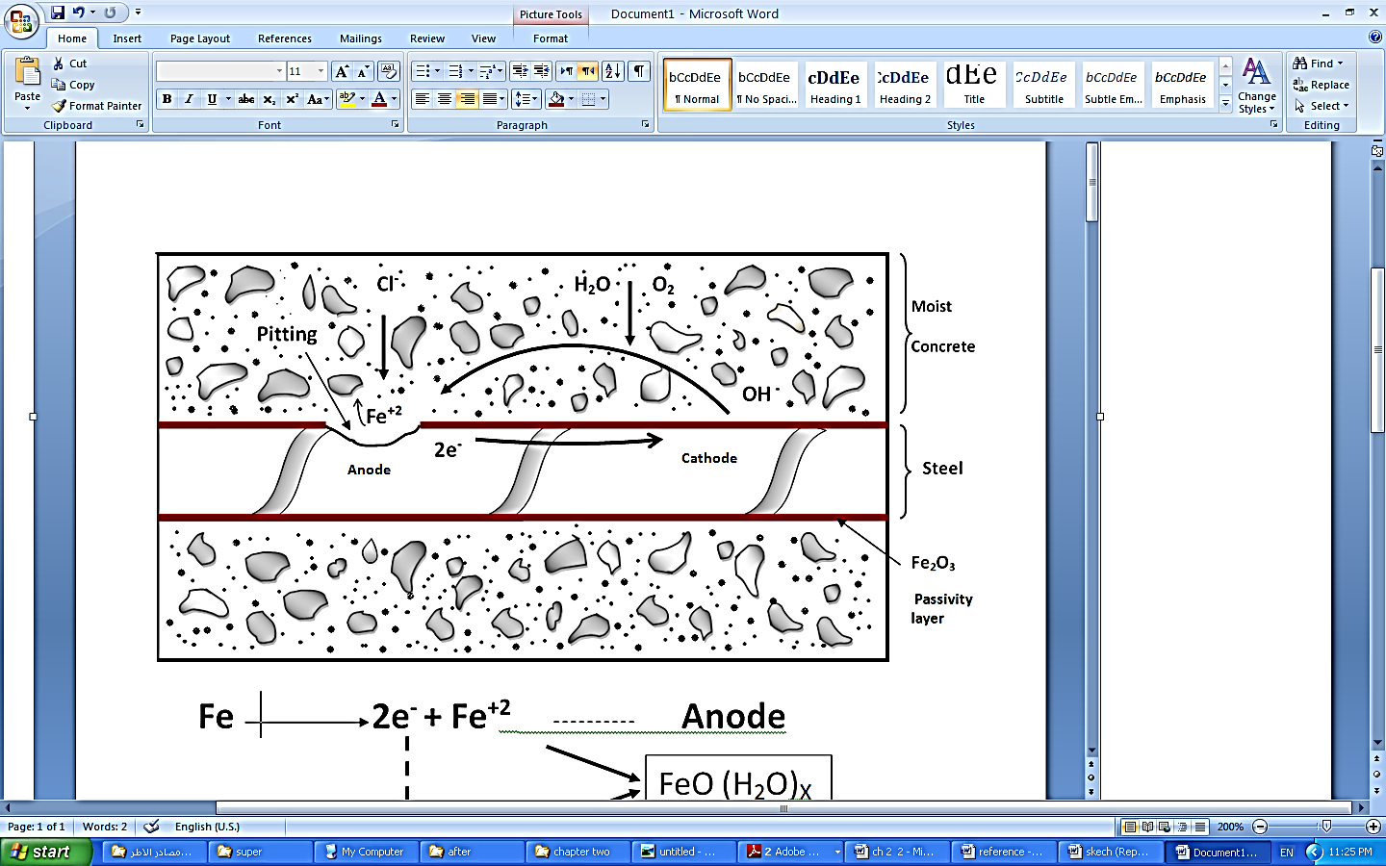
Figure-1: The process of corrosion of steel in concrete
if section within the sloped portion of … as in Eq. (2):
$$V_{p}=f_{ps assumed} A_{ps} \frac{e_{mid}-e_{anchor}}{L_{ps}-X_{between deviators}}$$ | $$Eq.(2)$$
The resulting iron oxide is highly water-absorbing and poorly adheres ... as in Table-1.
Table-1: Some international and Arab codes specify reinforced concrete with a maximum aggregate size of 20 mm and a compressive strength of more than 25 N/mm²
Limits | ACI 318-2011 | 8110: Part 1:1985 | IS 456:2000 | Code of design [17] 1997
Water to cement ratio  (max limit) | 0.4 | 0.45 | 0.45 | 0.42
Concrete cover (mm)  (min limit) | 50 for walls and tiles  62 for the rest | 50 | 50 | 35 for walls and tiles  0.4 for the rest
REFERENCES
[1] ACI Committee 222R (2001) 'Corrosion of Metals in Concrete', Manual of Concrete Practice.
[2] Civjan, S. A., Lafave, J. M., Lovett, D., Sund, D. J. and Trybulski, J. (2003) 'Performance Evaluation and Economic Analysis of Combinations of Durability Enhancing Admixtures (Mineral and Chemical) in Structural Concrete for the Northeast USA', Prepared for the New England Transportation Consortium, New England, USA.
[3]الحبوبي، سهير كاظم., شاهر, حيدر عبد الكريم., محمد, رواء علي., فنجان, بثينة. (2013) "إنتاج خرسانة عالية المقاومة والديمومة باستخدام المواد المحلية"، دائرة بحوث البناء.
[4] (1997) "كودة تصميم وتنفيذ المنشآت الخرسانية المسلحة", الكودات العربية الموحدة لتصميم وتنفيذ المباني.
[5] (2002) "Guidebook on non-destructive Testing of Concrete Structures', International Atomic Energy Agency, Vienna.

